February 2, 2022
To: Associate Professor Luke Wilson
Chair, Arts and Sciences Curriculum Committee
Re: Approval of Master of Arts in String Pedagogy and Master of Music in String Performance
At its meeting on Wednesday, January 19, 2022, the ASCC Arts & Humanities Panel 1 unanimously approved a revision to the Master of Arts in String Pedagogy and Master of Music in String Performance. Because of a significant number of retirements, course offerings have changed to the extent that the School of Music’s graduate programs are being forced to adapt. Many courses are no longer offered, and new courses have not yet been placed within the School’s graduate curricula. The string faculty are therefore designing a curriculum with more breadth and rigor, and the revised curriculum opens opportunities for students to explore broader concepts in pedagogy.
The revision to the Master of Arts in string pedagogy includes:
- Removing Music 8810.32, 8810.33 and 7852.03.
- Removing Music 5648, 5649, 6786, 7741, 7742, 8850, 5621 and 5622 from Elective 1 and Elective two lists.
- Moving Music 8810.31 a required course to an elective course
- Adding Music 6786, 5591 6752, 8820 and 8895 to list of electives
- Reducing the total number of credits from 33 to 30 hours.
The revisions to the Master of Music in string performance includes:
- Removing Music 7852.03 and 6786 research methods and bibliography
- Adding Music 7208.03 Small ensemble strings to supportive studies
- Increasing course elective credits from two to three and alter list of disciplines from which the electives can be taken.
- Adding Music 8810.31 and 8895
- Reducing the total number of credits from 32 to 30
We advance the proposed revisions to the Arts and Sciences Curriculum Committee with a motion to approve.
Sincerely,
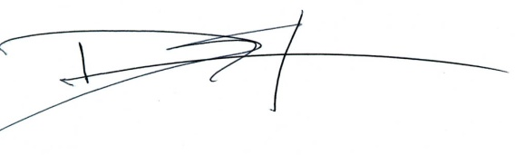
David J. Staley, Ph.D.
Associate Professor of History
Faculty chair, ASCC Arts & Humanities Panel 1

